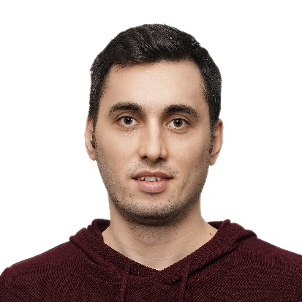**Mehmet Saygılı**

**Personal Information**

**Adres Bilgileri:** Tuzla/ISTANBUL

**Mobile:** 0 537 793 99 32

**Email:** mehmathsaygili@gmail.com

**Date of Birth:** 04.05.1985

**Education**

**2004 – 2010 University (Bachelor's Degree): Yıldız Technical University, Istanbul –** Faculty of Engineering, Mathematics Engineering

**Work Experience**

**10.2021 - Present Softtech,** Istanbul – Turkey

**Team Leader**

* Leads a group of employees to achieve goals that contribute to the growth of the organization

**05.2014 - Present Softtech,** Istanbul - Turkey

**Software Analyst**

|  |
| --- |
| * Developed and supported new and existing projects. |

**05.2012 – 05.2012 Softtech,** Istanbul - Turkey

**Software Engineer**

|  |
| --- |
| * Developed and supported new and existing projects |

**08.2011-05.2012 Softtech,** Istanbul - Turkey

**Software Development Specialist**

|  |
| --- |
| * Developed and supported new and existing projects |

**Projects**

**Kripton (2018-2019)**

* Designed an application suite using Pega to manage the entire credit lifecycle, from application to disbursement, in a modular structure.
* Contributed to the commercial credit leg of the project and provided support to the disbursement module.
* Played an active role in the requirement and design phases of the process.

**Ant (2016-2019)**

* Managed the transition process from IMS db to DB2, which involved moving data throughout the bank to a new database structure and creating common modular structures.
* Evaluated new projects that followed one after the other in this context and transitioned to new service models in backend transformations.

**Cash Flow (2015-2016)**

* Designed a cash flow system to monitor all types of disbursements, repayments, interest, accruals, etc. processes in a common structure for all loans.

**NAR Transformation Project (2013-2015)**

* Transformed commercial credit disbursement screens from old Java technology to .NET framework and connected them to each other with customer-based processes by including them in a common service infrastructure.

**Skills**

**Language Skills:**

* English: C1

**Programming Languages:**

* Python, Java, Cobol, C#

**Database Technologies:**

* SQL, DB2, Oracle, MongoDB, IMS

**Technologies and Application Frameworks:**

* Flask, Django, IBM Mainframe, Spring, .NET, Web Services

**Tools:**

* Visual Studio Code, Intellij, Eclipse, SoapUI, Git, Maven, Toad for Oracle,

Unity, PyCharm, PowerDesigner, Visual Studio

**Additional Information**

**Hobbies and Interests:** Chess (Professional), Basketball, Cinema, Music, Theatre

**Smoking:** None

**References**

**Orkun Uğur,** Solution Architect - Softtech

Phone: +90 (542) 261 36 67

**Alper Sadık Bilgil,** Solution Architect - Softtech

Phone: +90 (533) 492 31 72